Texas Small Farmers & Ranchers
Community Based Organization
REGION 5

MANAGING gRASSLANDS

Date: Saturday, March 12, 2016
Time: 11:00 AM
Place: El Arbol Restaurant, Wolfe City, Texas

Presenter: Kalissa Garland, District Conservationist,
United States Department of Agriculture (USDA),
Natural Resources Conservation Service (NRCS), Bonham, Texas

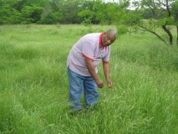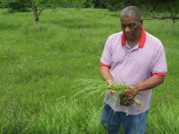
(Photo of Robert Brown – TSFR/CBO Rancher & Landowner, Greenville, Texas)
Share the Cost Lunch (No more than $10 per person)
Bring other farmers & ranchers that may be interested!
Directions to: El Arbol Restaurant, Wolfe City, Texas

From business hwy. 69, Greenville, Texas, Exit North on Hwy. 34
(To Wolfe City)
Restaurant is located at 110 E. Main, Wolfe City, Texas 75096
(Downtown) Wolfe City.

Hosted by: Troy S. Mumphrey, TSFR/CBO Regional Coordinator
(cell) 903.312.2016 & David Mims, TSFR/CBO Region 5 Chairperson
& Robert Brown, TSFR/CBO Region 5 Rancher & Landowner

